Determinants of Alzheimer

After removing the missing values and rows with Group = “Converted”, we proceed with the analysis.

Analyse using descriptive statistics (both graphical and numerical representations) on the dataset project data.csv. Generate an appropriate table as summary and appropriate graphs (e.g., boxplots, histograms and scatterplots).

Here we look at the relationship between independent variables and dependent variable

- Gender and Alzheimer (Demented) or not (Non-demented)

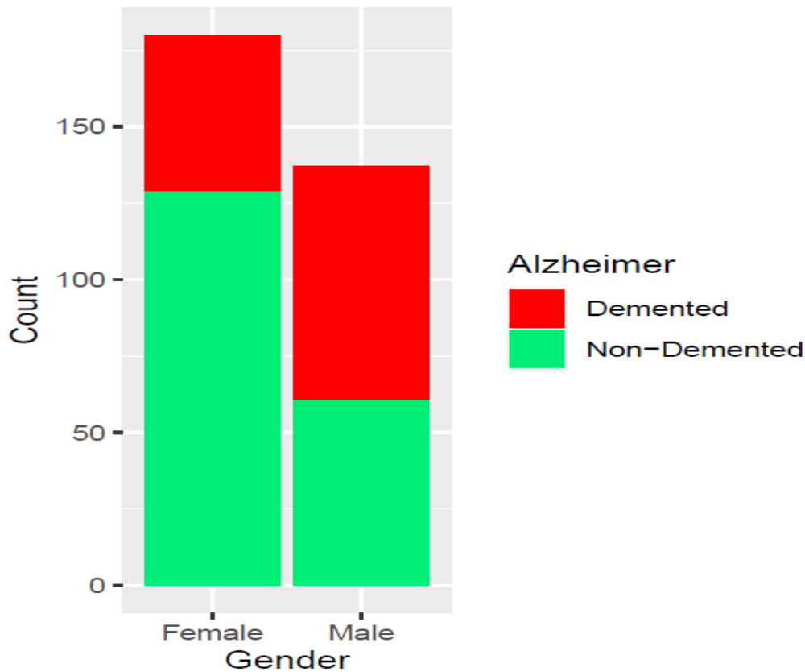

From the above graph in the given sample, males have high count of Alzheimer as compared to females. The proportion of males and females who have Alzheimer are 55% and 28% in the given sample. Females have a higher representation than males in the sample (Females are 180 and Males are 137). Total sample size is 317.

- Age and Alzheimer (Demented) or not (Non-demented)

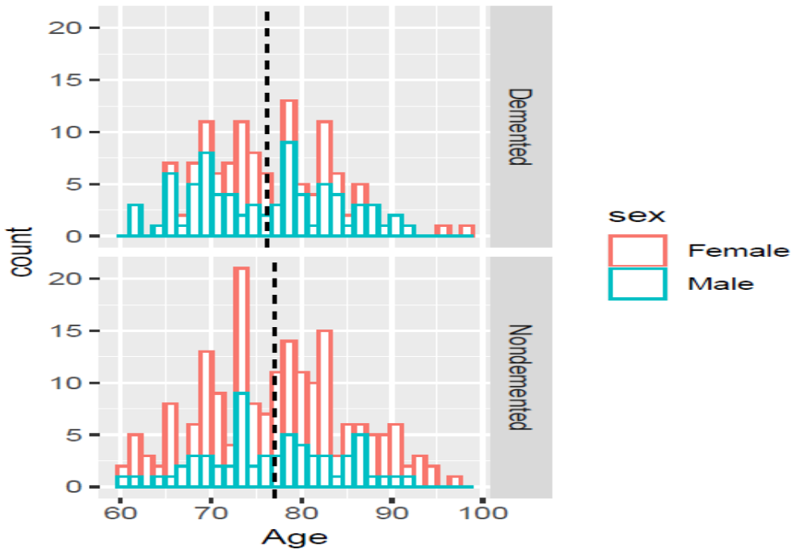

The persons who have Alzheimer have an average age of 76.20 years while the persons who do not have Alzheimer have an average age is 77.06 years.

- Education and Alzheimer (Demented) or not (Non-demented)

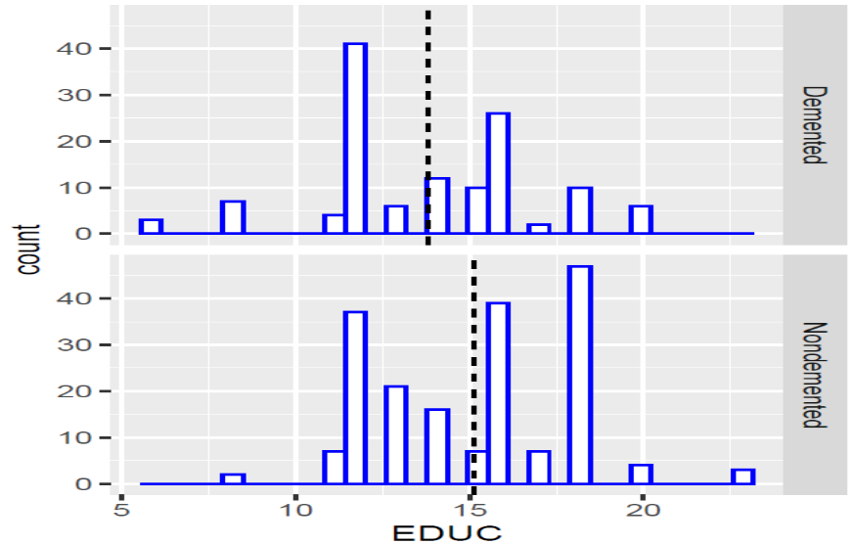
The educated persons who have Alzheimer have an average years of education of about 13.83 years while the educated persons who do not have Alzheimer have an average years of education of nearly 15.14 years.

- Socioeconomic Status and Alzheimer (Demented) or not (Non-demented)

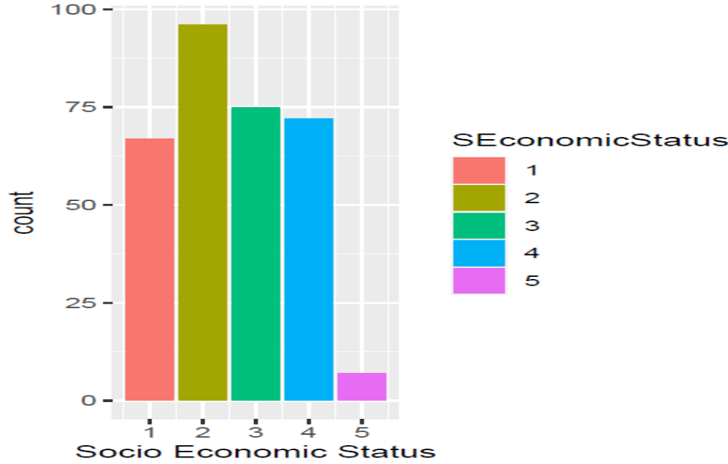

The lower socio economic status (=2) has the highest representation in the sample. The least representation in the sample is by the highest socio economic status (=5).

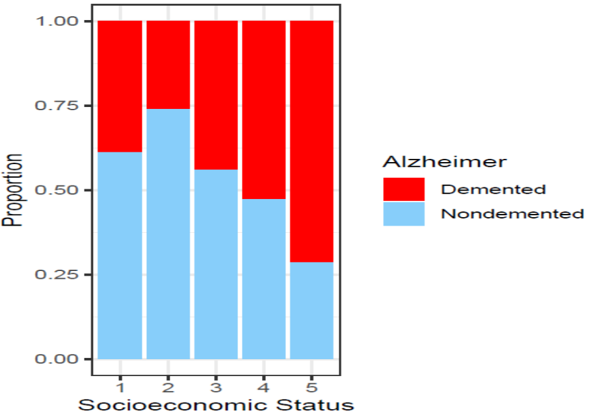

The highest proportion of Alzheimer is present in the highest socio economic status (=5). The least proportion of Alzheimer is present in lower socio economic status (=2)

